2010 MJC H2 Chemistry Prelim Paper 3 (Answers)

1(a) (i) For the amide, the electron-withdrawing effect of the carbonyl group reduces the electron density on the N atom, making the lone pair less available to accept a proton, hence it is a weaker base compared to the amine.

(ii) K_{b} = 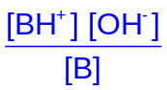
= 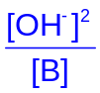

By approximation method,

[OH⁻] = 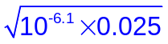
= 1.41 x 10⁻⁴ mol dm⁻³

pH = 10.1

(iii) Let x be the number of moles of HCl required, and v be the total volume.
pOH = pK_{b} + lg 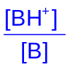
14 – 7 = 6.1 + lg 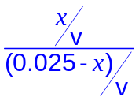

x = 2.23 x 10⁻²
Volume of HCl required = 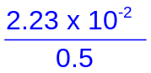
= 4.46 x 10⁻² dm³
= 44.6 cm³

(iv) When a small amount of base (OH⁻) is added,

OH⁻ + BH⁺ → H₂O + B

In the buffer solution, [OH⁻] is slightly changed and pH of buffer solution remains fairly constant.

(b) (i) K_{b} value of Procaine > K_{b} value of Lidocaine. For the 2 samples of equal concentration, number of free mobile ions for Procaine is greater than that of Lidocaine.
(ii) Add aqueous Br₂ at r.t.p separately to each of the unknown compounds.

Reddish brown Br₂ decolorizes in Procaine and a white ppt is formed while reddish brown Br₂ does not decolorize in Lidocaine.

(iii)

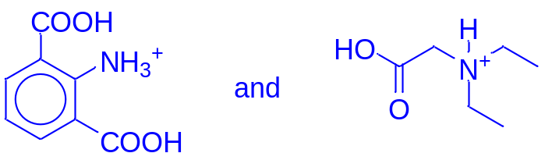
(c)
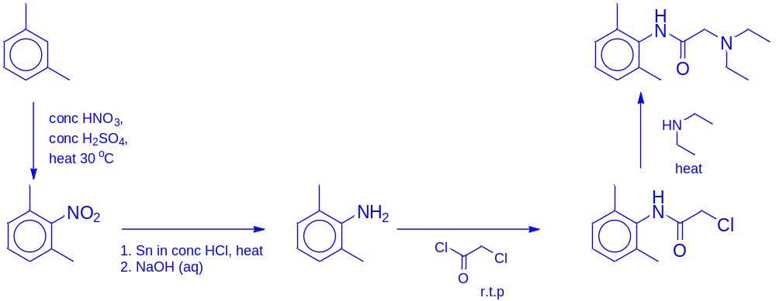
(d) (i) Reaction I: Reduction
Reaction III: Elimination

(ii) Perform Reaction II first, then Reaction I.

2 (a) (i) Metal X is the anode (oxidation)
Ni²⁺ + 2e Ni Eº = -0.25 V
Eº _{cell} = Eº_{red} - Eº_{oxid} = -0.25 – Eº_{oxid} = + 0.51 V

Eº_{oxid} = -0.76V (for Zn²⁺ + 2e Zn)

X is Zn.

(ii)
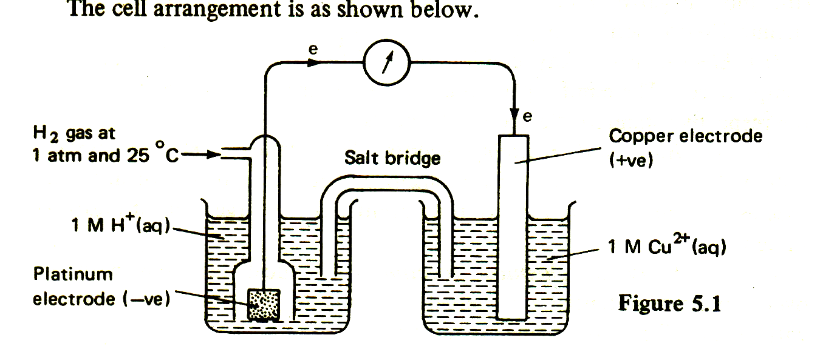
-

Ni

[Ni²⁺(aq)] = 1 mol dm⁻³

[H⁺(aq)]
= 1 mol dm⁻³

^{Pt}

(iii) Ni²⁺ + 2e Ni Eº_{Ni2+/Ni}

On adding NaOH, [Ni²⁺] will decrease due to the formation of Ni(OH)₂ precipitate. By Le Chatelier’s Principle, position of equilibrium will shift left to increase [Ni²⁺] so E_{Ni2+/Ni} becomes less positive and E_{cell} will be less positive.

(b) Ni²⁺ + 2e → Ni
No of moles of Ni = 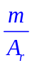=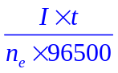
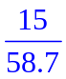=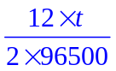

t= 4110 s = 1.14 hrs

(c) (i) Anode: CH₃CH₂OH + 3 H₂O → 2 CO₂ + 12 H⁺ + 12 e
Cathode: O₂ + 4 H⁺ + 4 e →2 H₂O
Overall eqn: CH₃CH₂OH (l) + 3 O₂ (g) → 2 CO₂ (g) + 3 H₂O (l)
(ii) Ethanol produces twice as many electrons per mole of alcohol than methanol

OR

CH₃CH₂OH + 3H₂O → 2CO₂ + 12 H⁺ + 12e
CH₃OH + H₂O → CO₂ + 6 H⁺ + 6e

(iii) (1) C₂H₆.
(2) PV = nRT = 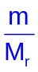RT
101000 x 142 x 10⁻⁶ = 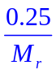x 8.31 x (127 + 273)
M_{r} = 57.9 ≈ 58.0
V is C₄H₁₀.
(3) C_{x}H_{y} + 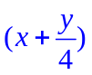 O₂ → xCO₂ + 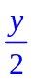 H₂O

Volume of excess O₂ + CO₂ = 180 cm³
Since NaOH absorbs acidic CO₂ gas.
➔ Volume of excess O₂ =60 cm³
➔ Volume of CO₂ = 180 – 60 = 120 cm³
➔ Volume of O₂ used for combustion = 250 – 60 =190 cm³

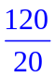= x 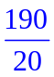=
x = 6 y = 14

➔ W is C₆H₁₄.

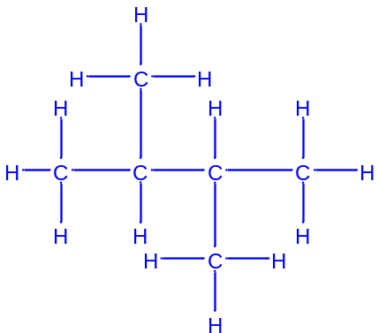
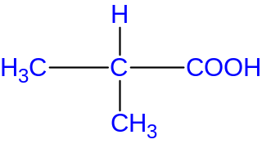
(4)
S is CH₃COOH, T is

3 (a) (i) From the plot of P_{N2} against time,
Half life is almost constant at 19 min
Hence, order of reaction wrt N₂O = 1.

(ii) Rate = k[N₂O]

t_{1/2} = = 19
k = 0.0365 min⁻¹

(b) Rate = k[NO]²[H₂]

(c) (i) Iron can act as a heterogeneous catalyst because of the availability of 3d and 4s electrons for temporary bond formation with reactants.

(ii)
Kinetic Energy
Number of particles with given energy

E_{a, cat}
E_{a, uncat}
No. of particles with E > E_{a} for catalysed reaction
No. of particles with E > E_{a} for uncatalysed reaction

The iron catalyst increases the rate of reaction by providing an alternative reaction pathway of lower activation energy. Number of reactant particles with E ≥ E_{a} increases, Frequency of effective collisions increases. Since rate of reaction is proportional to the frequency of effective collisions, rate of reaction increases.

(d) (i) For Fe³⁺(aq), in the presence of the H₂O ligands, the d orbitals are split into two groups. This effect is known as d orbital splitting. The d electrons undergoes d-d transition and are promoted to the higher d orbital.

During the d-d transition, the d electron absorbs a certain wavelength of light from the visible region of the electromagnetic spectrum and emits the remaining wavelength which appears as the colour of the complex observed.

For Sc³⁺(aq), there are no d electrons hence there is no d-d transition.

(ii) The brown solution is (aqueous) I₂

For solution of pH = 1, reaction between Fe³⁺ and I₂
Fe³⁺ + e⁻ Fe²⁺ E^{θ} = + 0.77V (reduction)
I₂ + 2e⁻ 2 I⁻ E^{θ} = + 0.54V (oxidation)
E^{θ}_{cell} = E^{θ}_{red} - E^{θ}_{oxid}
E^{θ}_{cell} = + 0.77 – (+0.54) = + 0.23 V ( > 0 feasible)

For solution of pH = 10, reaction between Fe(OH)₃ and I₂
Fe(OH)₃ + e⁻ Fe(OH)₂ E^{θ} = - 0.56V (reduction)
I₂ + 2e⁻ 2 I⁻ E^{θ} = + 0.54V (oxidation)
E^{θ}_{cell} = E^{θ}_{red} - E^{θ}_{oxid}
E^{θ}_{cell} = - 0.56 – (+0.54) = - 1.10 V ( < 0 not feasible)
Brown solution of I₂ is not formed.

(e) When dilute ammonia is added gradually,
[Cu(H₂O)₆]²⁺ + 2OH^{-..} Cu(OH)₂ + 6H₂O ----- (1)
A pale blue precipitate of Cu(OH)₂ is formed.

In excess ammonia,
[Cu(H₂O)₆]²⁺ + 4NH₃ [Cu(NH₃)₄(H₂O)₂]²⁺ + 4H₂O ----- (2)
NH₃ ligands replace H₂O ligands to form a deep blue complex [Cu(NH₃)₄(H₂O)₂]²⁺.

As [Cu(H₂O)₆]²⁺ is decreased, equilibrium position for Eqn (1) shifts to the left.
Hence, ionic product Cu(OH)₂ will decrease to the extent that it is less than K_{sp} of Cu(OH)₂. Pale-blue precipitate of Cu(OH)₂ dissolves.

4 (a) (i) Standard enthalpy change of neutralisation (ΔH_{n}^{θ}) is the energy released when an acid and a base react to form one mole of water at 298K and 1 atm (or standard conditions).

(ii) Actual quantity of heat evolved, Q’ = 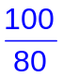 × (50+50) × 4.2 × 8.5
= 4462.5 J

2HCl(aq) + Sr(OH)₂ (aq) → SrCl₂ (aq) + 2H₂O(l)

n_{H2O} formed = 2 x n_{Sr(OH)2} reacted
= 2 x 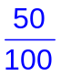 x 0.77 = 0.077
∆H^{ө}_{n} = -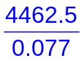
= − 58.0 kJ mol⁻¹
(iii) Aqueous ethanoic acid is a weak acid which dissociated slightly in aqueous solution.

Some of the energy evolved from the neutralisation process is used to further dissociate the weak acid completely .
(b)
Sr²⁺(g) + 2H⁺(aq) + 2OH–(aq) + 2e
Sr²⁺(g) + 2H₂O(l) + 2e
Sr(g) + 2H₂O(l)
Sr(s) + 2H₂O(l)
Sr²⁺(aq) + 2H⁺(aq) + 2OH–(aq) + 2e
ΔH_{at}(Sr)
Sr²⁺(aq) + 2OH–(aq) + H₂(g)
ΔH_{rxn}
1st & 2nd I.E (Sr)
2 x ΔH_{n}
ΔH_{hyd}(Sr²⁺)
ΔH_{rxn}(2H⁺ +2e)
ΔH_{rxn} – (164) – (548) – (1060) + 2 (-58) = - 1337 + (-850)
ΔH_{rxn} = - 299 kJ mol⁻¹

(c) (i) SrF₂ (s) 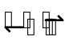 Sr²⁺ (aq) + 2F⁻ (aq)

K_{sp}(SrF₂) = [Sr²⁺][F⁻]²

2.5 x 10⁻⁹ = (s)(2s)²
s = 8.55 x 10⁻⁴ mol dm⁻³

SrSO₄ (s) Sr²⁺ (aq) + SO₄²⁻ (aq)

K_{sp}(SrSO₄) = [Sr²⁺][SO₄²⁻]²

3.2 x 10⁻⁷ = (s)²
s = 5.66 x 10⁻⁴ mol dm⁻³

Based on the calculated solubilities, SrF₂ is more soluble than SrSO₄.

(ii) SrF₂ (s) Sr²⁺ (aq) + 2F⁻ (aq)
NaF (s) → Na⁺ (aq) + F⁻ (aq)

There will be common ion effect due to the presence of F⁻. By Le Chatelier’s Principle, position of equilibrium will shift to the left to decrease [F⁻]. The solubility of SrF₂ is reduced. The solubility product of SrF₂, K_{sp}, is not affected as it is only dependent on temperature.

(iii) (1) When BaCl₂ and SrCl₂ are mixed,
[Ba²⁺] = 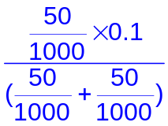= 0.0500 mol dm⁻³

In the saturated solution of BaF₂,

Ionic pdt (BaF₂) = K_{sp}
(0.05)[F⁻]² = 1.7 x 10⁻⁶
[F⁻] = 5.83 x 10⁻³ mol dm⁻³

(2) For Sr²⁺ remaining in saturated solution of SrF₂,
Ionic pdt (SrF₂) = K_{sp}
[Sr²⁺][5.83 x 10⁻³]² = 2.5 x 10⁻⁹
[Sr²⁺]_{remaining} = 7.36 x 10⁻⁵ mol dm⁻³

(d) (i) ΔG_{ppt}^{θ} = 8.31 x 298 x ln (3.2 x 10⁻⁷)
= - 3.70 x 10⁴ J mol⁻¹
= - 37.0 kJ mol⁻¹

(ii) -3.70 x 10⁴ = - 1453 x 10³ – 298 x ΔS
ΔS = - 4750 J mol⁻¹ K⁻¹

(iii) ΔS is negative, as there is a change in phase from aqueous to solid state as Sr²⁺ and SO₄²⁻ ions forms solid SrSO₄ which results in a less disordered state / entropy decreases

5 (a) (i) Electron cloud size: 2-chlorobutane < 2-iodobutane
Extent of distortion of electron cloud:
2-chlorobutane < 2-iodobutane

Extent of intermolecular Van der Waal’s forces of attraction:
2-chlorobutane < 2-iodobutane

Less energy required to break weaker intermolecular forces of attraction between 2-chlorobutane molecules compared to 2-iodobutane molecules, hence lower boiling point.
(ii) Bond length of C–X: C–Cl < C – I
Bond strength of C–X: C–Cl > C – I
Ease of breaking of C–X bond: C–Cl < C – I
Ease of nucleophilic substitution / formation of X⁻:
2-chlorobutane < 2-iodobutane

Hence AgI (yellow) precipitate forms more quickly than AgCl (white) precipitate

(iii) For butanoyl chloride, the carbonyl C atom has two electronegative atoms (O and Cl) bonded to it compared to
2-chlorobutane with Cl as the only electronegative atom.

Due to the electron-withdrawing effects of O and Cl, the carbonyl C atom in butanoyl chloride is more electron deficient
than the halogenoalkane C, hence it is more susceptible to nucleophilic substitution.

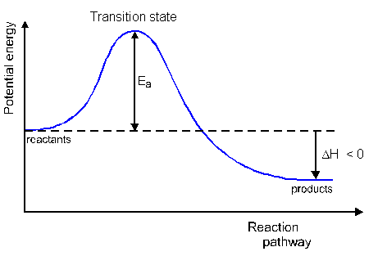
(b) (i)
Energy
E_{a}

(CH₃CH₂CH₂ CH₂Br + CN⁻)
CH₃CH₂CH₂ CH₂CN + Br-
ΔH
Reaction pathway
transition state

(ii) 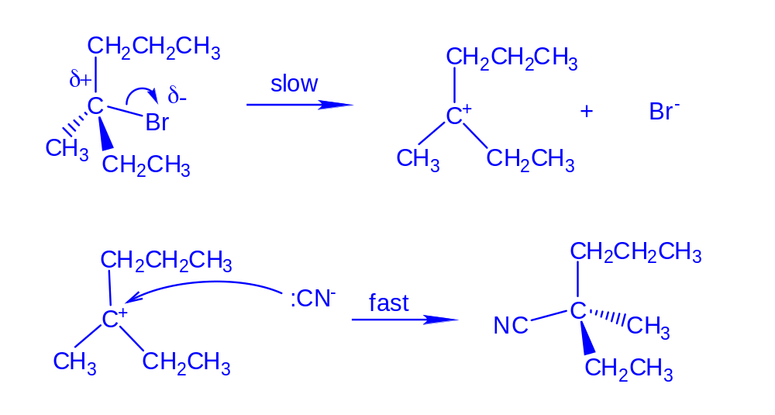
Compound G
(iii) Carbocation intermediate formed (sp² hybridised) is (trigonal)
planar, hence CN⁻ nucleophile has equal probability of attacking from either plane of the carbocation intermediate, forming a racemic mixture. The racemic mixture contains equal proportions of each
enantiomer, thus is optically inactive.

(c) Empirical formula of H = C₆H₁₀O
Since M_{r} = 98.0, molecular formula of H = C₆H₁₀O

H does not undergo nucleophilic substitution with PCl₅ but undergoes oxidation with hot acidified K₂Cr₂O₇
⇒ H is an aldehyde

H undergoes oxidation with hot acidified KMnO₄ to form I (C₄H₈O) and
2 moles of CO₂
⇒ H is an alkene

2 moles of CO₂ are formed from the oxidation forms ethanedioic acid
of CO₂

I undergoes nucleophilic addition with HCN to form J
⇒ I is a ketone
⇒ J is a cyanohydrin / hydroxynitrile

J undergoes reduction with LiAlH₄ in dry ether at r.t.p. to form K (C₅H₁₃NO)
⇒ K is an amine

H undergoes electrophilic addition with HBr to give L and M
⇒ H is an alkene
⇒ L and M are halogenoalkenes with chiral carbon / centres

